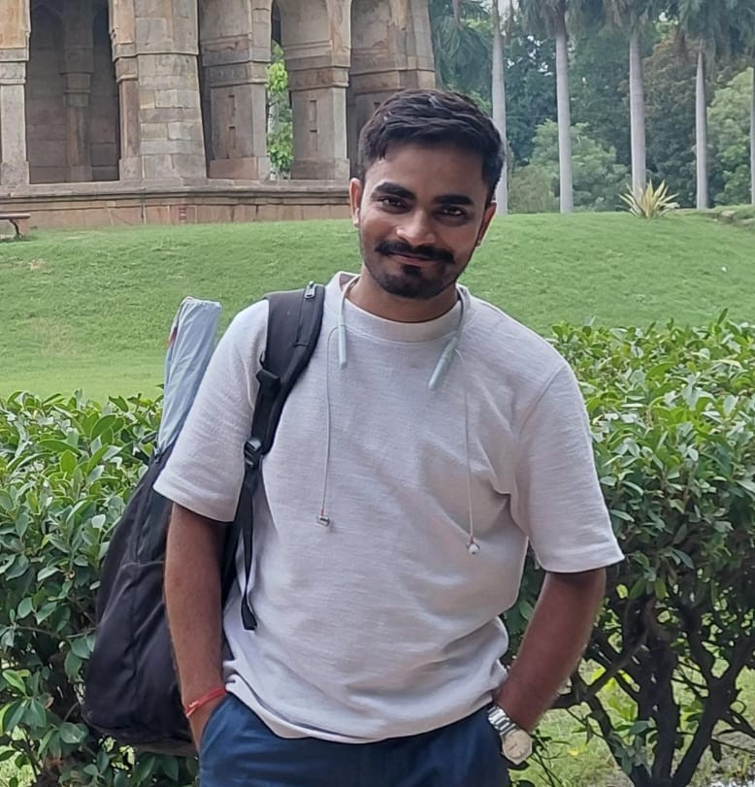

Front Photo “SURAJ KUMAR MANDAL” Link with Photo and description
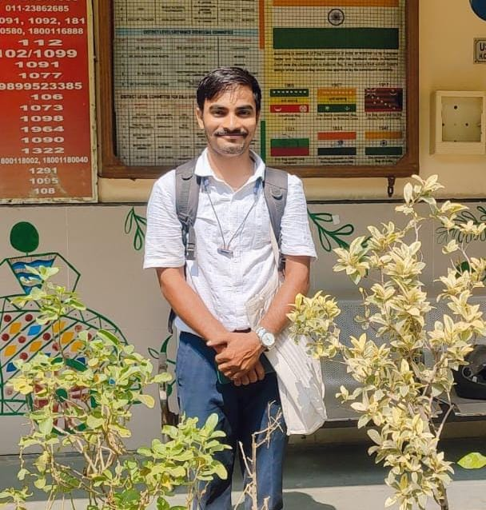

Suraj Kumar Mandal
Co-Founder & Trustee | Shikshadwar Foundation
Suraj Kumar Mandal is a dedicated social development professional and Trustee of Shikshadwar Foundation, with over five years of experience in designing and implementing community-based development programmes. His expertise spans education, youth development, public health, women's empowerment, environmental sustainability, community engagement, and corporate social responsibility (CSR).
Throughout his career, Mr. Mandal has worked with leading development organizations, including Read India, Center for Catalyzing Change (C3), TB Alert India, Sponsor A Child Foundation, Children International, and Blue Planet Environmental Solutions. He has successfully led initiatives focused on community mobilization, volunteer engagement, stakeholder coordination, programme implementation, and strengthening partnerships with government departments, educational institutions, healthcare providers, and corporate CSR partners.
As Co-Founder of Shikshadwar Foundation, Mr. Mandal provides strategic leadership in advancing the organization's mission of ensuring equitable access to education, employability, and sustainable livelihood opportunities for underserved communities. He plays a key role in programme planning, institutional development, partnership building, volunteer management, and the implementation of impactful interventions that empower children, youth, and women to achieve their full potential.
His commitment to excellence has earned him national recognition, including the Best Pragati Mitra – North India (2024) and Best Pragati Mitra – India (2025) awards under the Amazon CSR-supported Read India initiative. He has further enhanced his professional capabilities through specialized certifications from globally and nationally recognized institutions, including the World Health Organization (WHO), the Indian Council of Medical Research (ICMR), UNICEF, CBSE-DIKSHA, and the Delhi Commission for Protection of Child Rights (DCPCR).
Mr. Mandal holds a Master of Social Work (MSW) from Indira Gandhi National Open University (IGNOU). Guided by the principles of equity, collaboration, and sustainable development, he remains committed to building resilient communities by expanding access to quality education, skills development, health awareness, and inclusive opportunities that enable individuals to lead dignified and self-reliant lives.

